**Course Learning Outcomes:**

Upon completion of this assignment, you should be able to:

| CLO1 | Explain the essential facts, concepts, principles, strategies and theories relating to Information Technology applications. (C2, PLO1) | Class Test |
| --- | --- | --- |
| **CLO2** | **Demonstrate intellectual independence, logical and analytical thinking skills to develop creative and innovative solutions for a range of Information management and IT problems. (C3, PLO2)** | **Individual Assignment** |
| **CLO3** | **Communicate effectively and professionally with peers, clients, superiors and society at large both in written and spoken form. (A3, PLO5)** | **Individual Assignment** |

1. **INDIVIDUAL ASSIGNMENT DESCRIPTION**

This is an individual assignment, you are required to design, implement and document your solution as per the requirements on your programme.

**Engineering Programme**

**Hydroponic farming system**

The hydroponic system is a controlled climate system in which the crops can grow year-round. The system is designed to grow crops without soil in a smaller space and optimize water consumption. The plant roots grow in a liquid nutrient solution or inside moist inert materials like Rockwool and Vermiculite, hence it requires continuous attention to the crops.

It is crucial to continuously monitor and control the temperature, water level, humidity, lighting and nutrition of the crops to produce healthy crops.

You are required to design and develop a program to monitor and control the hydroponic system. The hydroponic system comprises many hardware, including but not limited to Fertigation and dosing, temperature, and humidity controller, timer and water pump.

The system should have the following features

* Calculate the amount of water/nutrition to be dispensed based on the current crops conditions (crops health, pH level, humidity, temperature, light etc)
* Keep a log of temperature, air and water condition.
* Display relevant information such as water level, humidity, temperature and light intensity.
* Schedule the duration and frequency of the watering and lighting cycle.
* Adjust the air to control the crops' environment with desired humidity and temperature
* Alert user when the measurement falls outside of the acceptable range (temperature or water is too low)

In your design, you are required to choose an appropriate PIC Microcontroller, study the datasheet and determine the pins for the inputs and outputs of the program.

**For example**

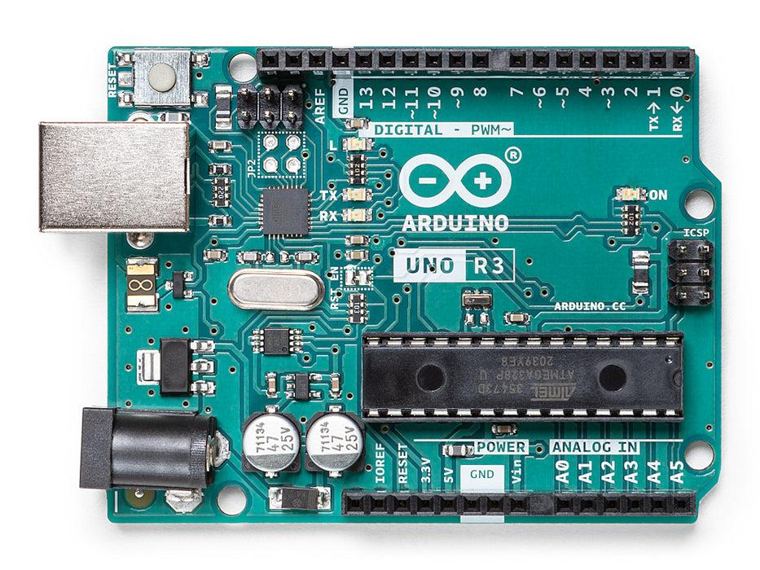

Microcontroller Arduino Uno Rev3

Dataset can be assessed from : <http://ww1.microchip.com/downloads/en/DeviceDoc/Atmel-7810-Automotive-Microcontrollers-ATmega328P_Datasheet.pdf>

**CGD Programme / Computer Science Programme**

**Slingshot Games**

A slingshot is a small toy or weapon used for "shooting" stones. Players start the game by selecting and loading the desired ammo, then set the angle to aim the target object. The process is followed by pulling back the pouch containing the ammo (force) and releasing it once everything is in place. The ammo is projected forward and hits the target.



You are required to develop a console application for the slingshot game, where one point will be awarded for every shot that hits the target. Use your creativity in writing the storyline of your game. The figure below shows the game architecture, where each game consists of a Game Application layer, a Game logic and a Game View. You need to implement the requirements stated in each component.

Game Application layers

* Configure/setup the initial view and logic of the game
* Manage the overall game progress and able to end the game and reset the game

Game View

* Create a simple console view where the program will accept inputs from the user and update the state and event of the player. There should be a menu, message, game start and end screens.
* Do not emphasize on the graphic / UI or sound elements of the game.

Game Logic

* Program the game logic by choosing appropriate data, implementing the load, aim and release events to shoot the target object. The component must include the slingshot physics as in the distance, speed and force of shooting.

The slingshot game menu sample will look as follow.

**Computer Science Programme / IT Programme**

**Personal Task Management System**

A Personal Task Management System is used to help users to manage and monitor their tasks. The system will help them to be more organized, productive and efficient in completing their work.

Users have to enter the task name, due dates and select a category when adding a new task into the system. They can search and view the existing tasks, or delete any existing tasks. Any data entry mistakes and completed tasks can be updated by modifying the existing records (tasks) by correcting the task name, due date, category and status.

The system menu shown in the figure above shows a list of functionalities of a Personal Task Management system. The system should include but not limited to the functionalities listed in the menu. Use your creativity to design and develop a personal task management system to help users to monitor and manage work progress. You are encouraged to review any existing Personal Task Management Systems available on the shelf and add on any suitable additional features on top of the basic requirements provided.

The Personal Task Management system should have the following requirements;

* Add a new task to the system.
* Manage the tasks by,
  + Updating the task information; name, category, due date and status, or
  + Deleting any unwanted tasks or data entry mistakes.
* Sort and view tasks in ascending or descending order with reference to the due date, category or etc.
* Retains the task information/record in a file.

1. **REQUIREMENTS**
2. You are required to carry out extra research for your system and document any logical assumptions you made after the research.
3. Your program should use symbolic constants where appropriate. Validations need to be included to ensure the accuracy of the system. State any assumptions that you make under each function.
4. You are required to store all data ina textfile.
5. You are expected to use control structures, functions, array, pointers, structures, unions and files in your program. Your program must embrace modular programming technique and should be menu-driven. Functions of similar operations can be grouped (or kept alone) and stored as separate C files. Header files are to be stored separately as .h files.
6. You may include any extra features which you may feel relevant and that add value to the system.
7. There should be no need for graphics (user interface) in your program, as what is being assessed, is your programming skill not the interface design.
8. You should include the good programming practice such as comments, variable naming conventions and indentation**.**
9. In a situation where a student:
   * + ***Failed to attempt the assignment demonstration, overall marks awarded for the assignment will be based on the documentation and design components only with a maximum 40 marks.***
     + ***Found to be involved in plagiarism, the offence will be dealt in accordance to APU regulations on plagiarism.***
10. You are required to use portable ANSI C programming language to implement the solution. Use of any other language like C++/Java and etc. is not allowed. Global variable is not allowed.
11. Results of a comprehensive testing is to be included in your document in the form of Input/Output screenshots with sufficient explanation. The tests conducted shall take into consideration of all valid inputs and negative test cases.
12. **DELIVERABLES**

You are required to submit:

1. A softcopy of the program coded in C – submitted in Moodle. The program should include the following:

* Basic C concepts such as displaying and reading of text, variables, and assignment of values, comments – to explain various parts of the program, etc.
* Intermediate C concepts such as control structures – selection and iteration control structures, use of arrays – single / double scripted, string.
* Advanced C concepts such as functions – programmer defined and library functions, pointers, structures, unions, linked list and files.
* Any other features of C that has not been covered.

1. A documentation of the system, that incorporates basic documentation standards such as header and footer, page numbering and which includes

* Cover page
* Table of contents
* Introduction and assumptions
* Design of the program – using pseudocode **and** flowchart – which adheres to the requirements provided above
* Additional features which have been incorporated in the solution in terms of design and C codes (sample segment of source code from the system created)
* Sample outputs when the program is executed with some explanation of the outputs / sections of the program
* Conclusion
* References – Harvard Name Referencing

1. Files to be uploaded to Moodle (ONLY FOLLOWING 3 FILES):
   1. **Documentation file** (.pdf)
   2. **Program / Source files** (.c files), **Header files** (.h files) and **text file** (archived as single .zip or .rar file)
   3. **Presentation video link (public access)** (refer to Appendix 1 for guide for making video presentation)
2. Submission

* All three files to be uploaded to Moodle
* Refer to the Moodle for the assignment deadline.

1. **ASSESSMENT CRITERIA**
2. CLO2: Design solution (Pseudocode and Flowchart) 20%

Detailed, logical and application of appropriate idea.

1. CLO2: Coding / Implementation 30%

Appropriate application of C concepts (from basic to advance), good solution implemented with validation and met all the requirements with additional features.

1. CLO2: Documentation 20%

Overall standard and layout, referencing (Harvard), Input/Output screen capture and assumptions.

1. CLO3: Demonstration 20%

Know how to execute and able to trace the system.

1. CLO2: Question and Answer 10%

Answered the questions based on the assignment submitted during presentation.

1. PERFORMANCE CRITERIA

Distinction (75% and above)

This grade will be assigned to work which meets all requirements stated in the question. The program runs smoothly when executed. There is clear evidence and application of C concepts up to advanced level. The program solution is unique with excellent coding styles and validation. The program implemented maps completely against the design (pseudocode and flowchart) as seen in the documentation. The design of the solution varies in styles and has unique logic with hardly any errors / omissions. The documentation does not have any missing components. Sample outputs documented have clear explanation. All work is referenced according to Harvard Name Referencing convention. Student must be able to provide excellent explanation of the codes and work done, show additional concepts / new ideas used in the solution, able to answer all questions posed with accurate / logical answers / explanation provided with sound arguments and clear discussion. Overall an excellent piece of work submitted.

Credit (65%-74%)

This grade will be assigned to work which of good standard and meets most of the requirements stated in the question. The program runs smoothly when executed. There is clear evidence and application of C concepts up to at least intermediate level. The program solution is unique with good coding styles and validation. The program implemented maps well against the design (pseudocode and flowchart) as seen in the documentation. The design of the solution varies in styles and has unique logic with minor errors / omissions. The documentation does not have any missing components. Sample outputs documented with some explanation. All work is referenced according to Harvard Name Referencing convention but with some minor errors / omissions. Student must be able to provide good explanation of the codes and work done, answer most questions posed with mostly accurate / logical answers / explanation. Overall a good assignment submitted.

Pass (50%-64%)

This grade will be assigned to work which meets at least half of the basic requirements (approximately 50%) stated in the questions. The program runs smoothly when executed. There is clear evidence and application of C concepts at basic level. The program solution is common with basic coding styles and validation. The program implemented somewhat maps with the design (pseudocode and flowchart) as seen in the documentation. The design of the solution is average in terms of logic and style with some errors / omissions. The documentation has some missing components. Sample outputs documented but without any explanation. Did some referencing but not according to Harvard Name Referencing convention and with some minor errors / omissions. Student must be able to explain some codes and work done and able to answer some questions posed with some accurate / logical answers / explanation. Overall an average piece of work submitted.

Fail (Below 50%)

This grade will be assigned to work which achieved less than half of the requirements stated in the question. The program is able to compile but not able to execute or with major error. The program solution has only basic coding styles with no validation. The program solution has little or no mapping with the design. The design of the solution has major / obvious errors / omissions. The documentation has some missing essential components. No referencing. Student is barely able to explain the codes / work done and answer given on the questions posed but with mostly inaccurate / illogical answers / explanation. Overall a poor piece of work submitted.

APPENDIX 1: Guidelines for Making Video Presentation

Steps before recording:

1. Make sure your camera and mic are in working condition.

2. Make sure the mic volume is adjusted or set to an appropriate level.

3. Make sure the camera is facing you and your face is fully visible throughout the recording session.

4. Open ALL your program files in Visual Studio or Visual Studio Code or Dev C++ or Code Blocks or any other suitable IDE and ensure the font size is not too small.

5. Open the folder where the text file(s) is/are created and keep the folder minimized.

START Recording

1. Introduce yourself (name, TP number, intake, programme of study, level and semester) – max 30 sec

2. Indicate the C and header files you created. Tell what each of them contains. You need to open each of them one-by-one while indicating – max 1 minute.

3. Now, show the C program where the program will start its execution. Explain the program starting from the execution point (from menu function, the input expected, selection of function for each input given to menu function). Note: You **need not** have to explain the code but the inputs to menu function and the selection of functions according to the user input – max 1 minute.

4. Now, show the C file (one-by-one) and explain the internal working of each function. You need to walk through the code (with mouse pointer precisely pointing the line of code you are explaining) - max 6 minutes.

5. Now, compile and run the program (pause the recording if computer takes a lot of time to compile and run) – max 30 sec.

6. Type your first option input to the menu function. Provide all data required. Exit the program. Open the text file created. Display and explain what data written in it. Close the text file (do not minimize).

7. Repeat step 6 for other options one-by-one. Display the changes that takes place in the text file(s). Max 1 minute for each option.

**Important: Make sure you share all your screens while recording.**

STOP Recording

If required, you may need to use the video editors to edit the unwanted frames out. If needed, use online video editors to fast forward your video to keep the duration short (10 to 15 minutes).

**YOU WILL BE REQUIRED TO COME ONLINE (AS THE PER AGREED DATE & TIME) AND ATTEND THE Q&A SESSION (UNLESS ADVISED BY ME) TO COMPLETE THE DEMO AND Q&A PROCESS. THE ACCEPTANCE OF YOUR VIDOE PRESENTATION IS BASED ON THE ATTENDANCE TO Q&A SESSION.**